**1.INTRODUCTION:**

**1.1 Overview:**

As a multi-speciality clinic, we offer the best medical expertise in specialised treatments, from ophthalmology to endocrinology. What makes HealthHub Clinics different is the right combination of advanced diagnostics, proven medical expertise and specialised services that work together for your well-being.

**1.2 Purpose:**

As a Center of Excellence, HealthHub Clinics offers multi-disciplinary resources and smart healthcare solutions, supported by a holistic and compassionate approach, understanding and quality care designed around your health.

**2.PROBLEM DEFINITION & DESIGN THINKING:**

**2.1 Empathy Map:** 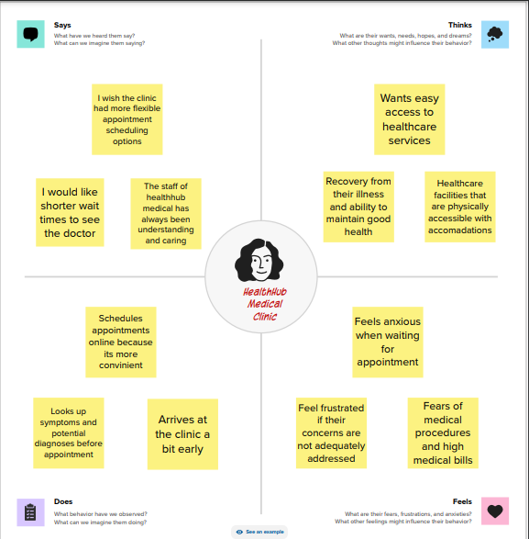

**2.2 Ideation & Brainstorming Map:**

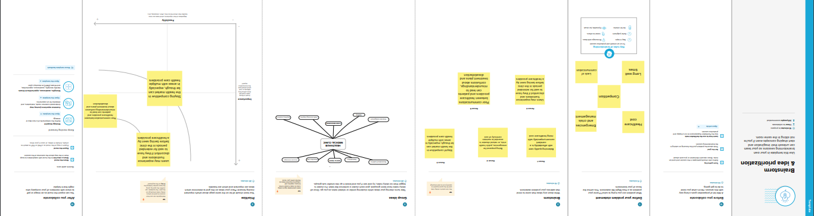

**3.RESULT:**

**PROFIT AND LOSS ACCOUNT:**

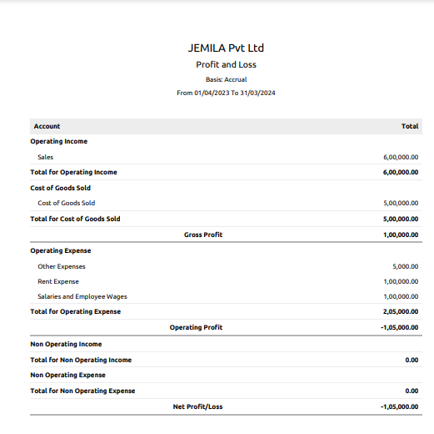

**BALANCE SHEET:**



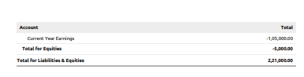

**4.ADVANTAGES & DISADVANTAGES:**

**ADVANTAGES:**

myHealthHub keeps patients connected to their loved ones and enables virtual care in hospital rooms. By engaging patients, it eliminates many administrative tasks for care providers and reduces the chances of readmission.

**DISADVANTAGES:**

The disadvantages of the health care plan are premiums increase with age, Pre-Existing Exclusion, Waiting Period for existing health problems, Co-Payment, etc. Health care coverage for families may cause an added financial burden.

**5.APPLICATIONS:**

Healthcare – Industry

**6.CONCLUSION:**

A conclusion is not merely a restatement or a summary, but it includes that in parts to paint a broader picture of the Scientific Research, its results, objectives and its inference to the overall field of study.

**7.FUTURE SCOPE:**

Healthcare degree enhances theoretical and practical skills to excel in areas of health tourism, research and medical information.